***Algorithmic Trading System Users Manual***

Algorithmic Trading Software

2024-04-09

Version 1.6

Authors: Jacob Rawlings,Jake Fischer**,** Alan Abdollahzadeh, Devon Volberg, William Blake, Benjamin Carrier, Vanessa Dubouzet, Dakota Flath, Parker Green, Yuan Hu, Jacob Labelle, Isaac Lengacher-Bergeron, Dominic Presch, Dylan Soares, Jaeden Soukoroff

**Revision Sheet**

| Revision | Date | Brief Summary of Changes |
| --- | --- | --- |
| Version 1.0 | 2023-11-21 | Baseline document draft |
| Version 1.1 | 2024-02-26 | Updated System Configuration Section (3) with ATS UI (3.3) |
| Version 1.2 | 2024-02-28 | Updated System Configuration  Updated Section (3) with ATS UI (3.3) |
| Version 1.3 | 2024-03-13 | Updated Section 3 (ATS UI) - Added Export Data |
| Version 1.4 | 2024-03-26 | Updated Section 3.3:   * Updated screenshots with new design * Added final instructions and screenshots for the Export Data page |
| Version 1.5 | 2024-04-07 | Updated Section 3.3:   * Updated screenshots with new design * Updated Job Scheduling |
| Version 1.6 | 2024-04-09 | Updated Section 3.3:   * Added creating user page |

**1. INTRODUCTION 1**

1. Definitions and Acronyms 1

**2. PREREQUISITES 1**

**3. SYSTEM CONFIGURATION 2**

**3.1 IONOS 3**

1. Logging into IONOS Account: 3

2. Accessing Databases on the IONOS panel: 3

3. Managing config files on IONOS: 5

**3. phpMyAdmin 7**

1. View table data on phpMyAdmin: 7

2. Make queries on phpMyAdmin: 7

3. Use of the queried data on phpMyAdmin: 7

3.3 ATS User Interface 12

1. Logging (Admin and Regular) 12

2. Changing System Configuration (Admin) 13

3. Job Scheduling (Admin) 15

4. Exporting Data 17

**4. APPENDIX 21**

Documentation 21

Help Page / Manuals 21

# INTRODUCTION

The purpose of this document is to serve as an operational guide. This manual outlines the main system configuration of the Algorithmic Trading System(ATS). Furthermore, there are instructions on how to access and manipulate the system through IONOS using phpMyAdmin.

## 1. Definitions and Acronyms

ATS - Algorithmic Trading System

RDBMS - Relational Database Management System

# PREREQUISITES

Users of the system will only require the following things to access it:

1. A modern Web browser such as Mozilla Firefox, Apple Safari, Google Chrome, Microsoft Edge, etc as long as you are using a visual web browser.
2. An Internet connection to connect with the IONOS web service.
3. Authorized credentials for logging into IONOS.

# SYSTEM CONFIGURATION

The ATS functions using four main system components:

1. IONOS
2. MySQL
3. phpMyAdmin
4. ATS User Interface



IONOS is a web hosting service that runs the ATS, including the databases, query making and data warehouse. IONOS provides the interface for the system and provides the server hosting.



* MySQL version 8.0

MySQL is the chosen open-source RDBMS. The RDBMS is meant to contain and manage information in a structured and efficient way using relational systems. MySQL handles all database operations for data storage.



* phpMyAdmin version 4.9.11
* PHP version 8.1

phpMyAdmin is a tool which provides a user interface to manage MySQL databases. IONOS, like many web hosting services, is outfitted with phpMyAdmin. This user interface will be the primary method of interacting with the database. It provides the functionality needed to create, view, modify, backup, and export data.



* ATS User Interface version 1.0

ATS User Interface is a web application which allows users to modify configuration files, scheduling jobs and export data. This will be the primary application that regular users use to export data efficiently.

## 3.1 IONOS

### Logging into IONOS Account:

* + Navigate using a web browser to [www.ionos.ca](http://www.ionos.ca) and click login.
  + Click “Sign In” at the top right corner then choose “Sign In” of “My Account”
  + Enter the given credentials. *(Figure 4.1)*

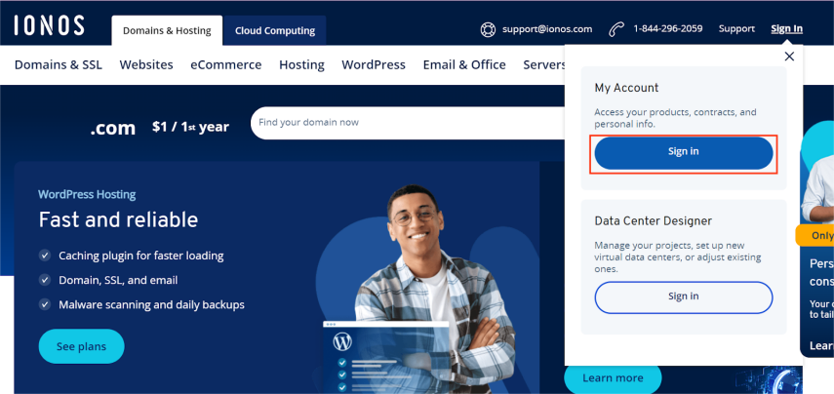*Figure 4.1 Ionos landing page*

### Accessing Databases on the IONOS panel:

* + Once successfully signed in, select the “Hosting” button from the homepage. *(Figure 4.2.1)*
  + Under the Databases section, Click “Manage”. *(Figure 4.2.2)*
  + Click “Open” under the “phpMyAdmin” header for the database you wish to manage. *(Figure 4.2.3)* 
    1. This will redirect to the phpMyAdmin page of the database. Refer to ***5. phpMyAdmin*** about how to query data on phpMyAdmin.

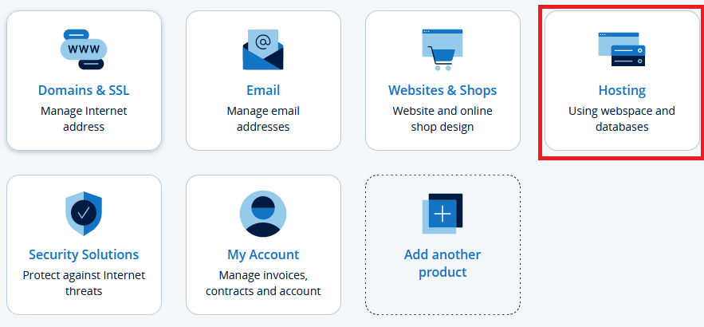

*Figure 4.2.1 Selecting hosting on Ionos*

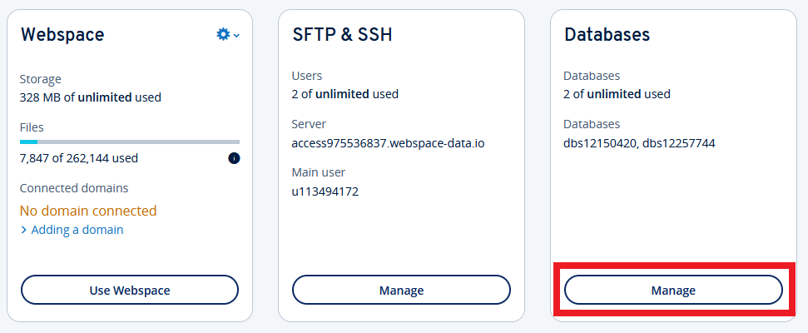

*Figure 4.2.2 Select manage databases in web hosting*



*Figure 4.2.3 Opening the ATS Database*

### Managing config files on IONOS:

* + Once logged into the IONOS panel, navigate to “Hosting”. *(Figure 4.3.1)*
  + Click “Use Webspace” to enter the online repository. *(Figure 4.3.2)*
  + There should be a directory tree structure on the left, navigate to the “/SFM_Project_2023/Data_Collection/Config/” to see all the configuration files. Config files can now be viewed or edited. *(Figure 4.3.3)*



*Figure 4.3.1 Selecting hosting on Ionos*

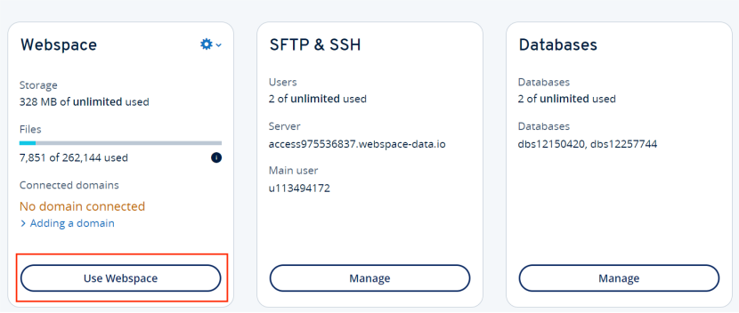

*Figure 4.3.2 Selecting use webspace in web hosting*

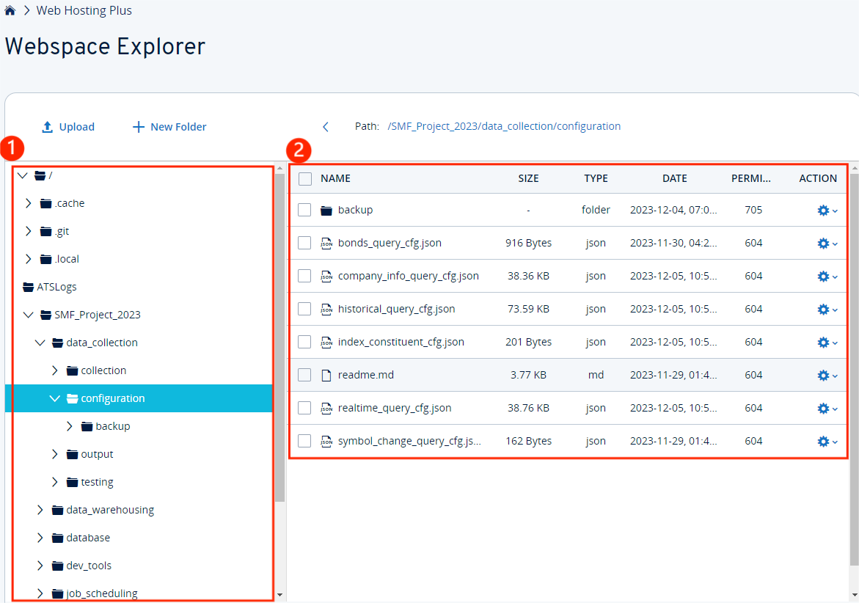

*Figure 4.3.3 Selecting configuration*

## 3. phpMyAdmin

### View table data on phpMyAdmin:

* + Select the preferred database (Figure 5.1.1).
  + Choose the table you wish to examine.
  + Table data will be displayed in the center of the screen.

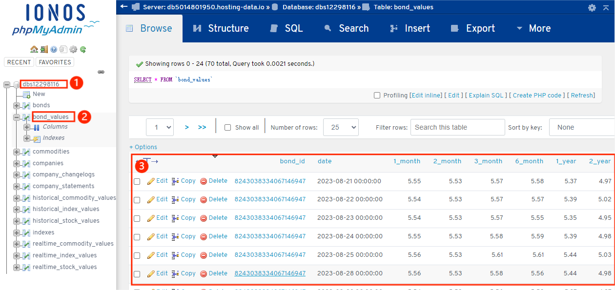

*Figure 5.1.1 Bond values table*

### Make queries on phpMyAdmin:

* + Navigate to the “SQL” page on phpMyAdmin.
  + Write SQL queries in the provided text area.
  + Click “Go” and query results will be displayed.

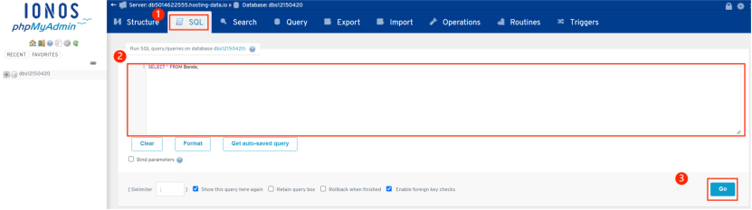

*Figure 5.2.1 Running SQL queries*

### Use of the queried data on phpMyAdmin:

* + When the output of the query is given, there are 5 options to manage it. (“Print”, “Copy to clipboard”, “Export”, “Display chart”, “Create view”). *(Figure 5.3.1)*
    1. Print
       1. Click “Print” and a template will be generated.
       2. Click the “Print” button and choose the printer. *(Figure 5.3.2)*
    2. Copy to clipboard
       1. Click “Copy to clipboard”.
       2. Paste the file where needed.
    3. Export
       1. Click “Export” and it will be redirected to the configuration page.
       2. Select the preferred export method, format, and rows then click “GO”. *(Figure 5.3.3)*
       3. The exported file will be sent to your downloads folder.
    4. Display chart
       1. Click “Display chart”.
       2. Specify the type of chart and other options accordingly.
       3. A chart is generated to visualize the selected data. *(Figure 5.3.4)*
    5. Create view
       1. Click “Create view”.
       2. Enter and edit the details of the view. *(Figure 5.3.5).*
       3. The view is generated on the left navigation bar. *(Figure 5.3.6)*

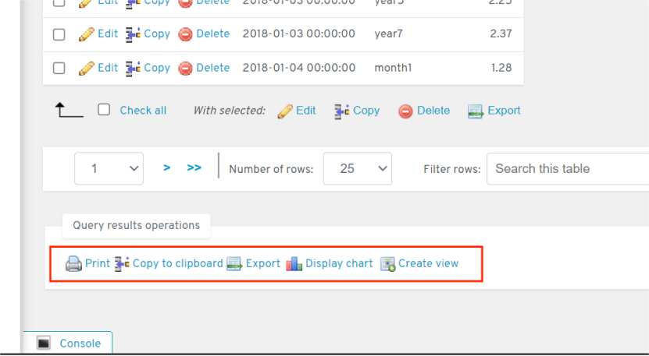

*Figure 5.3.1 List of operations available*

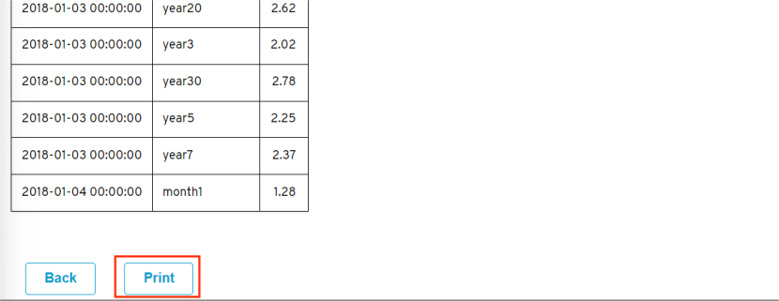

*Figure 5.3.2 Printing data from table*

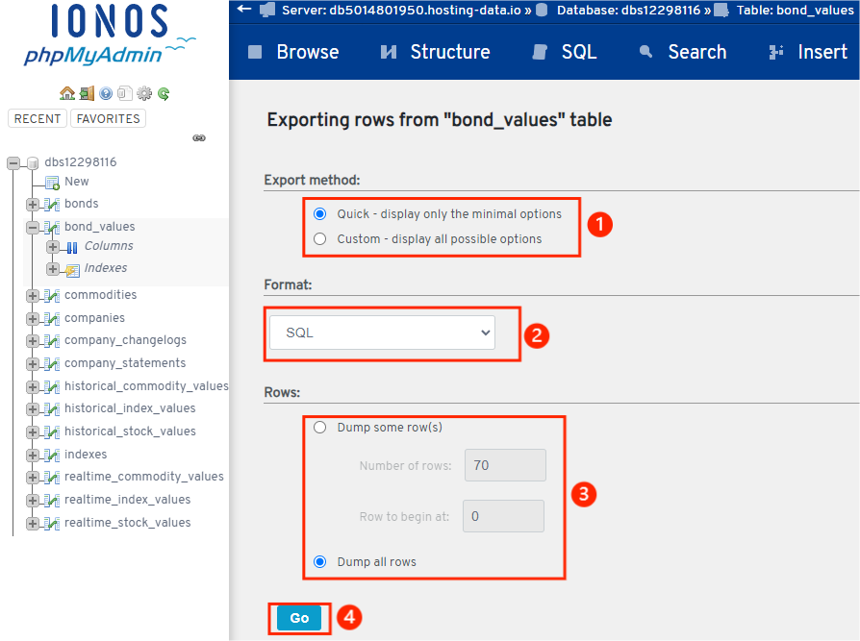

*Figure 5.3.3 Exporting SQL from bonds table*

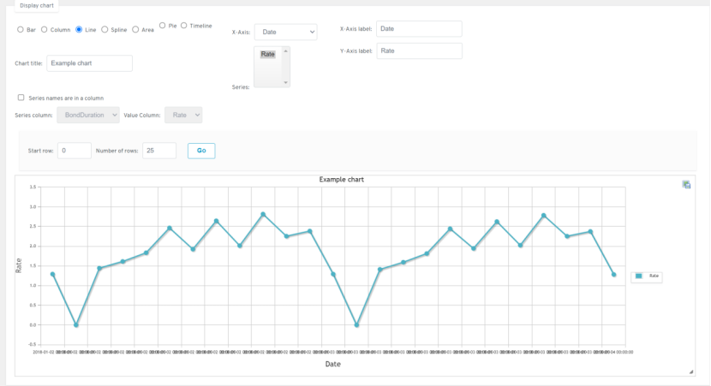

*Figure 5.3.4 Chart for visualizing data entry*

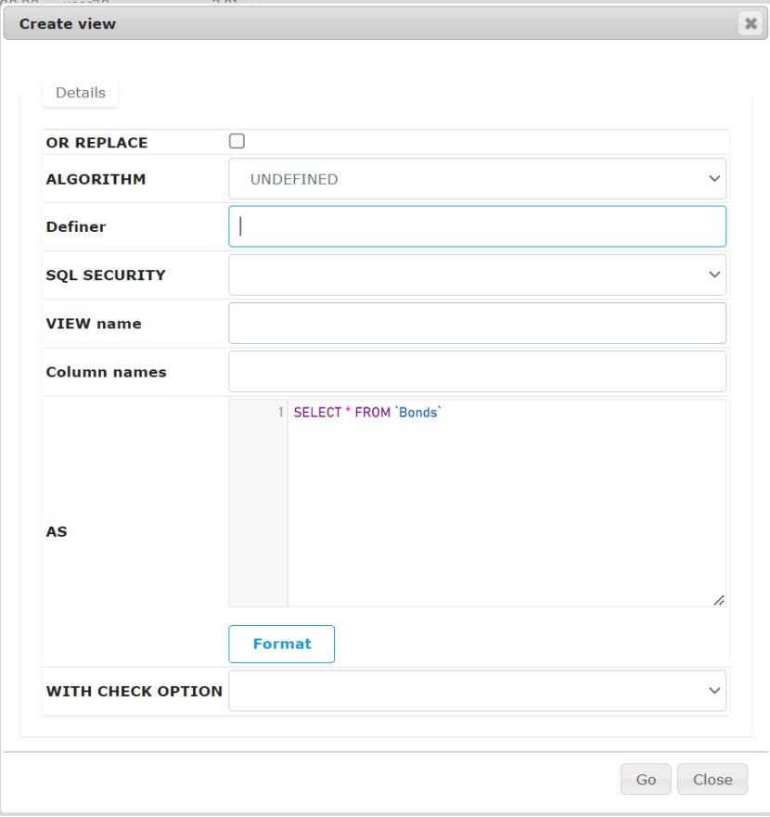

*Figure 5.3.5 Creating an SQL view*

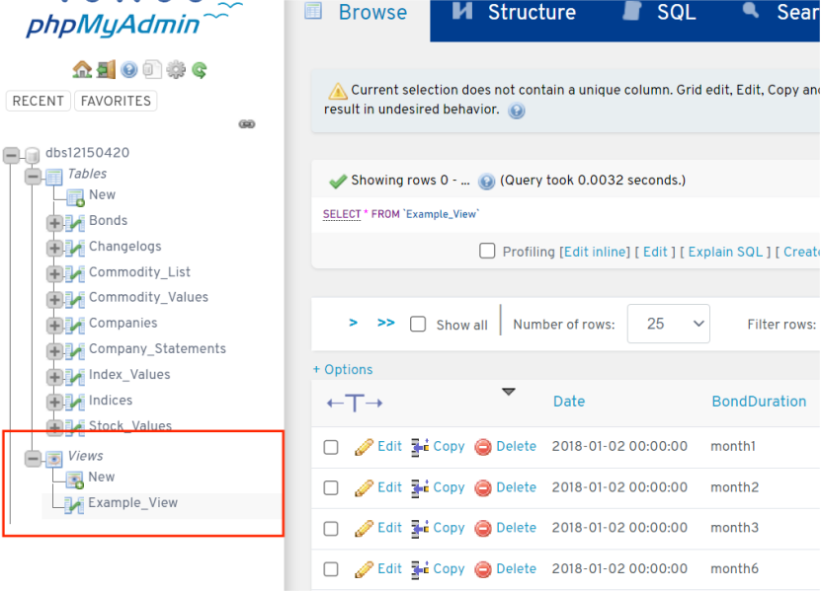

*Figure 5.3.6 List of created views*

## 3.3 ATS User Interface

### Logging (Admin and Regular)

* Navigate using a web browser to <https://ats.cosc-oc.ca/>
* Admin Login
  1. Enter valid admin credentials (*Figure 6.3.0*)
  2. Click “Log in”
* Regular Login

Note: Regular user accounts must be created by the admin before users can access the system.

* 1. Enter valid user credentials (*Figure 6.3.0*)
  2. Click “Log in”

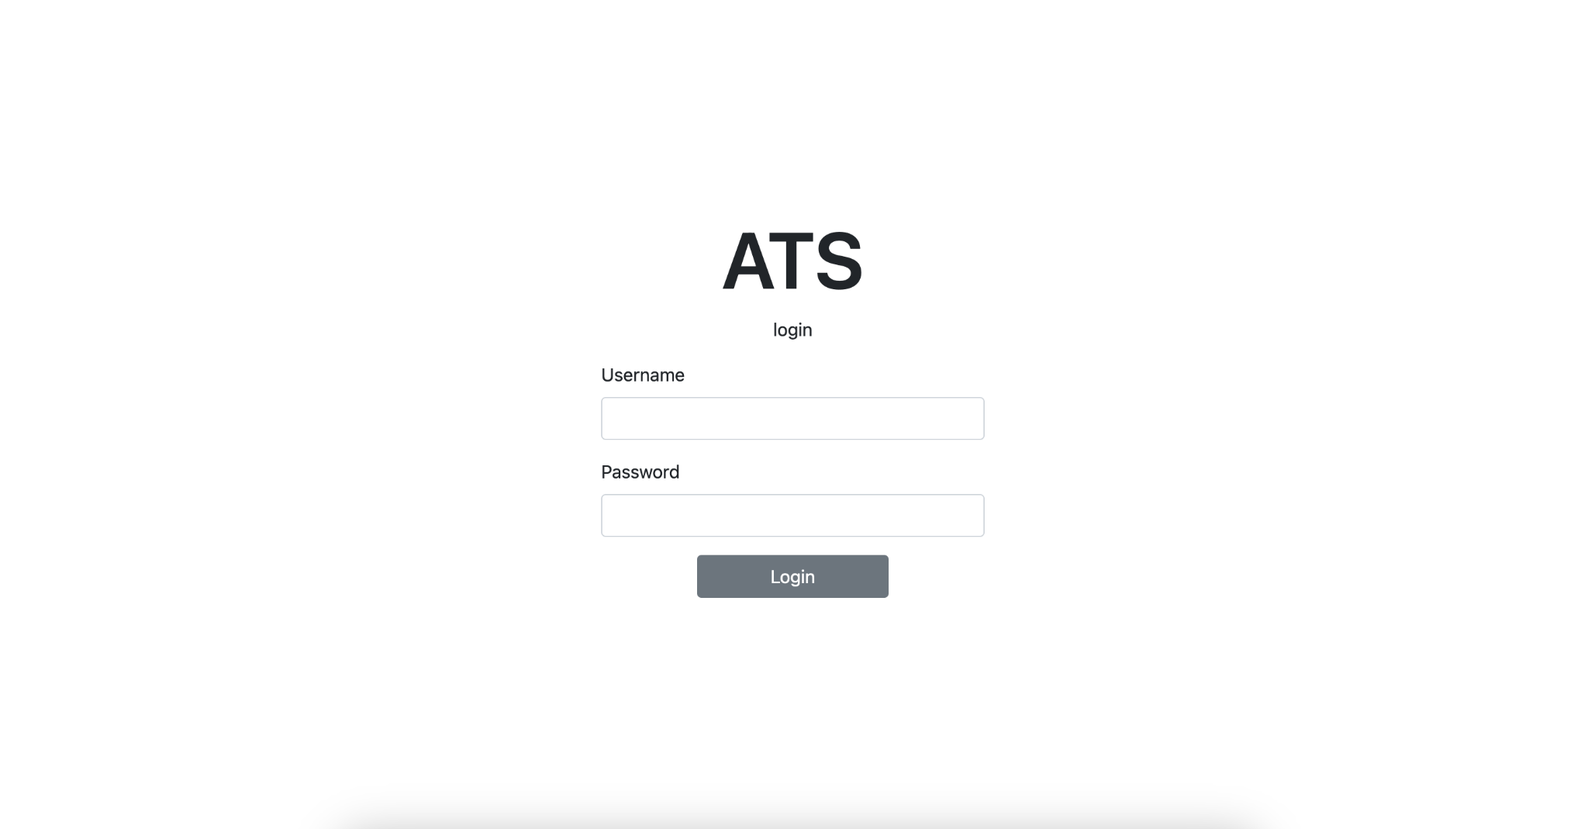

*Figure 6.3.0 ATS Login Page*

### Changing System Configuration (Admin)

* Once successfully logged in, navigate to Change Configuration Page (*Figure 6.3.1*)
  1. Changing Stock Configuration
     + Adding Stock
       1. Click “Add Stock” and a Add Stock Modal will appear.
          - Note: Loading time to query the data might take a while.
       2. Select the desired data that you wish to add on the configuration file. (*Figure 6.3.2*)
       3. Click “Add Stock” (*Figure 6.3.2*)
     + Removing Stock
       1. Click “Remove Stock” and a Remove Stock Modal will appear.
       2. Select the desired data that you wish to remove from the configuration file.
       3. Click “Save Changes”
  2. Changing Constituent Configuration
     + *Future development*
  3. Changing Data Sources
     + *Future development*

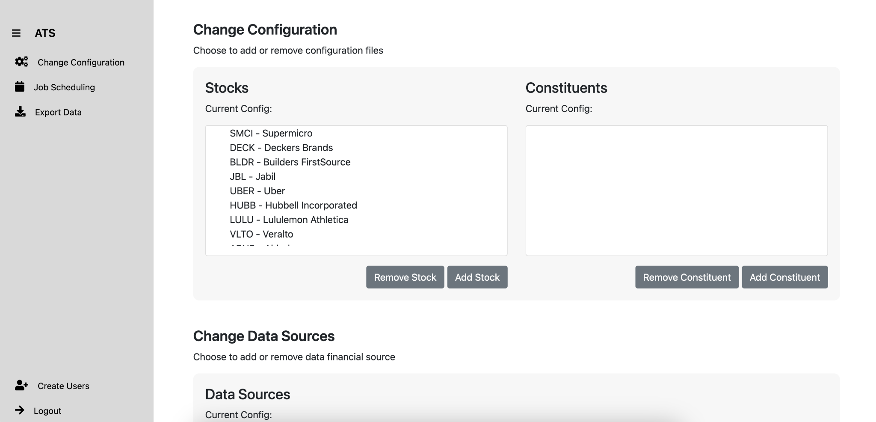

*Figure 6.3.1 Change Configuration Page*

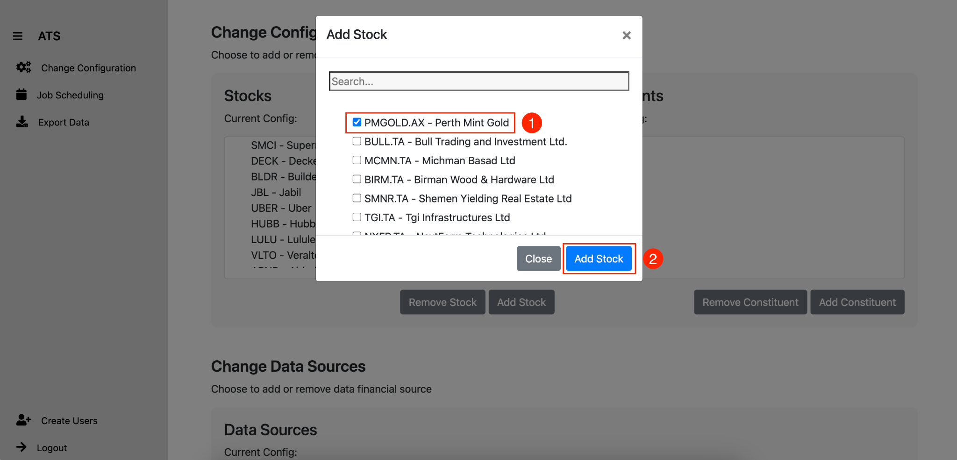

*Figure 6.3.2 Adding Stock Item to Configuration List*

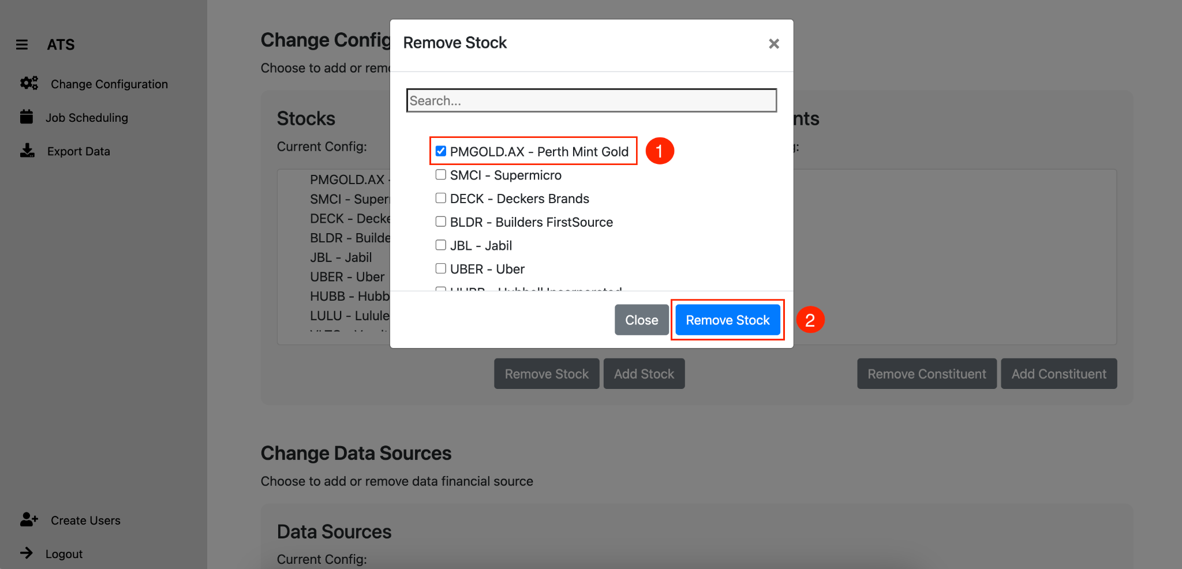

*Figure 6.3.3 Removing Stock Item from Configuration List*

### Job Scheduling (Admin)

* Once successfully logged in, navigate to Job Scheduling Page(*Figure 6.3.4*)
  1. Check the current jobs by selecting from the drop down list.(*Figure 6.3.5*)
  2. Modifying an existing job.
     + Select the job you wish to modify from the highlighted drop down list. (*Figure 6.3.6*)
     + Enter the time details into the adjacent fields.
     + Finally select apply changes below the time input boxes.

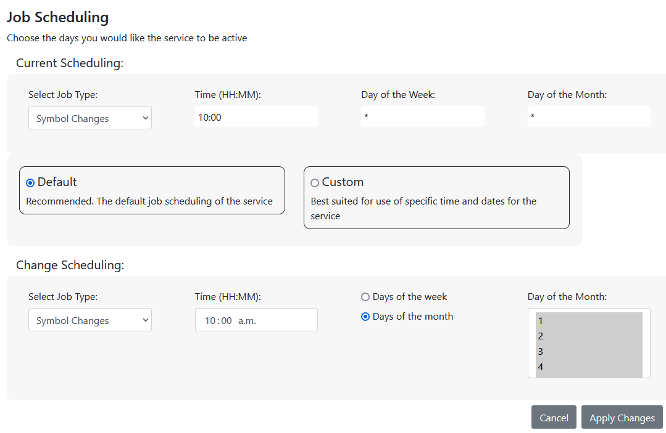

*Figure 6.3.4 Job scheduling landing page.*

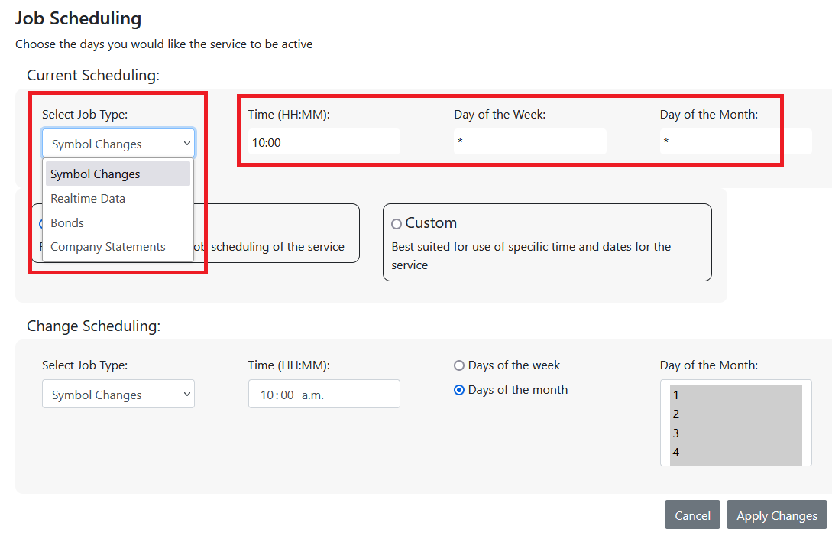

*Figure 6.3.5 Checking current job scheduling.*

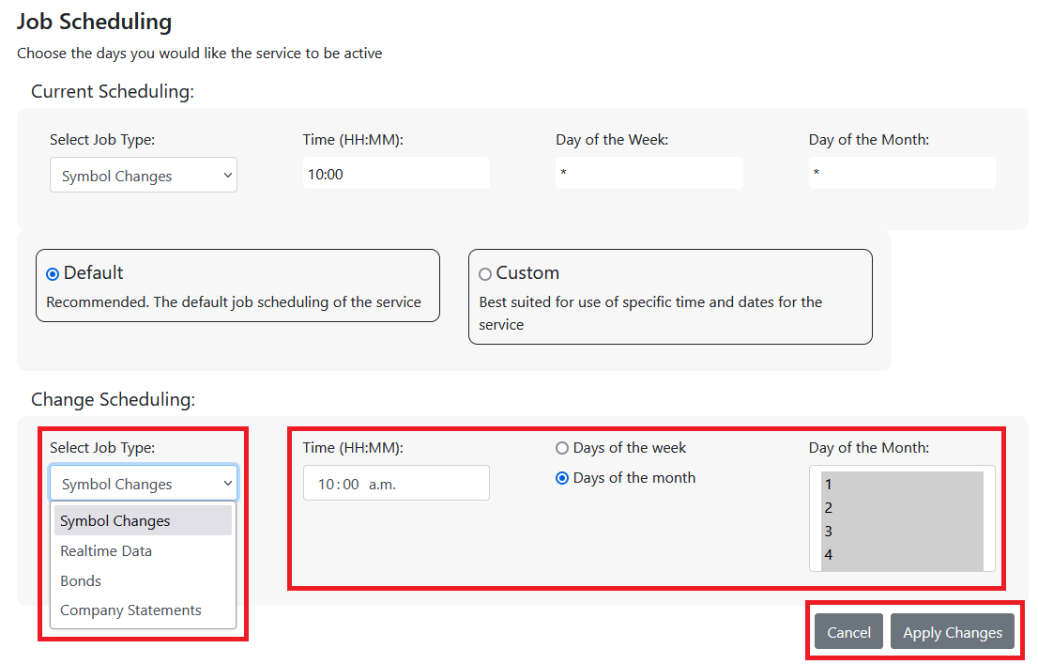

*Figure 6.3.6 Changing the current jobs.*

### Exporting Data

* Once successfully logged in, navigate to Export Data Page (*Figure 6.3.7*)
* **Selecting Data to download**
  1. Click “Select Data” dropdown to select which data you wish to download (*Figure 6.3.8)* 
     + You can choose between stocks, indexes, bonds, commodities, and company info.
  2. As you change between the options, you will see that the content in the “Select Data” and “Select Fields” lists will change based on your selection. Note the difference in fields between Stocks and Bonds data (*Figure 6.3.9)*
  3. Next, you can choose what entities (i.e. Stocks) you would like data for. Choose just a few, or hit the “Select All” button to export data for all entities in the database.
* **Selecting data fields**
  1. Under the “Select Fields” heading, you will see a list containing the fields for both the lookup and value tables associated with your data selection.
  2. Lookup Fields:
     + Fields that are used to uniquely identify entities within a data group (i.e. The ticker symbol and company name for any given stock)
  3. Value Fields:
     + Fields related to each entity such as stock price.
  4. Any fields can be deselected, however, all fields will be selected by default
* **Selecting Data Type**
  1. With the exception of Bonds and Company Info data, all data groups will have both realtime and historical data associated with them.
  2. Use the Data Type radio buttons to toggle between realtime and historical (*Figure 6.3.10)*
  3. Notice when you change the data type, the selected fields will change
     + From the current data source, historical and realtime queries return different fields. This is why we have them separated into separate tables.
* **Selecting Date Range**
  1. Click the dropdown to select the preferred date range you wish to download. (*Figure 6.3.10)*
  2. By default, the date range is set to get all data from 3 years in the past to the current date. (Only 3 years of data is retained in the database at one time)
* Click “Export File”, the exported file will be sent to your downloads folder in .csv format (*Figure 6.3.10)*

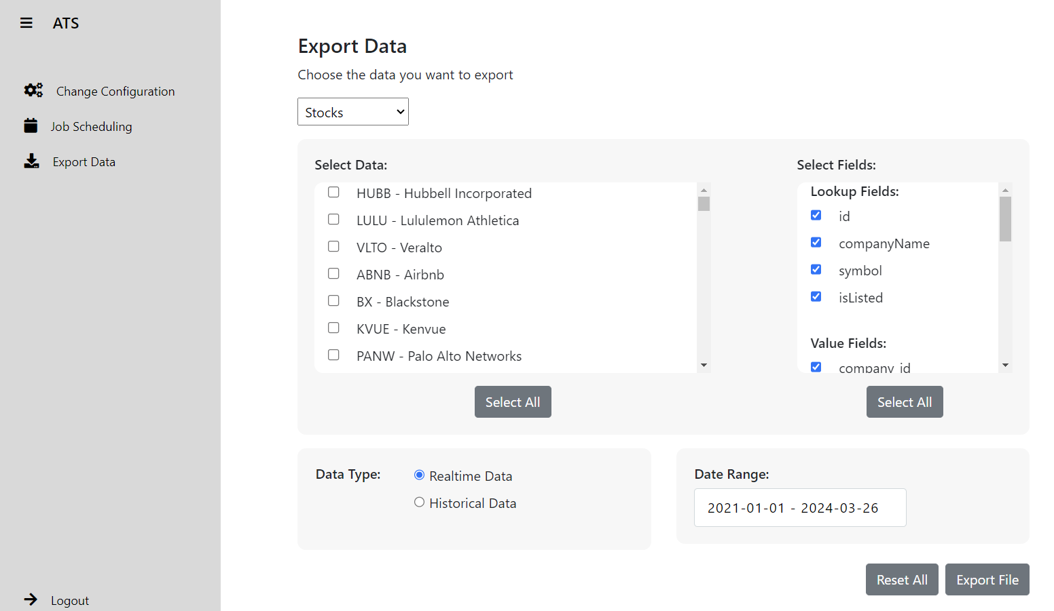

*Figure 6.3.7 Export Data Page*

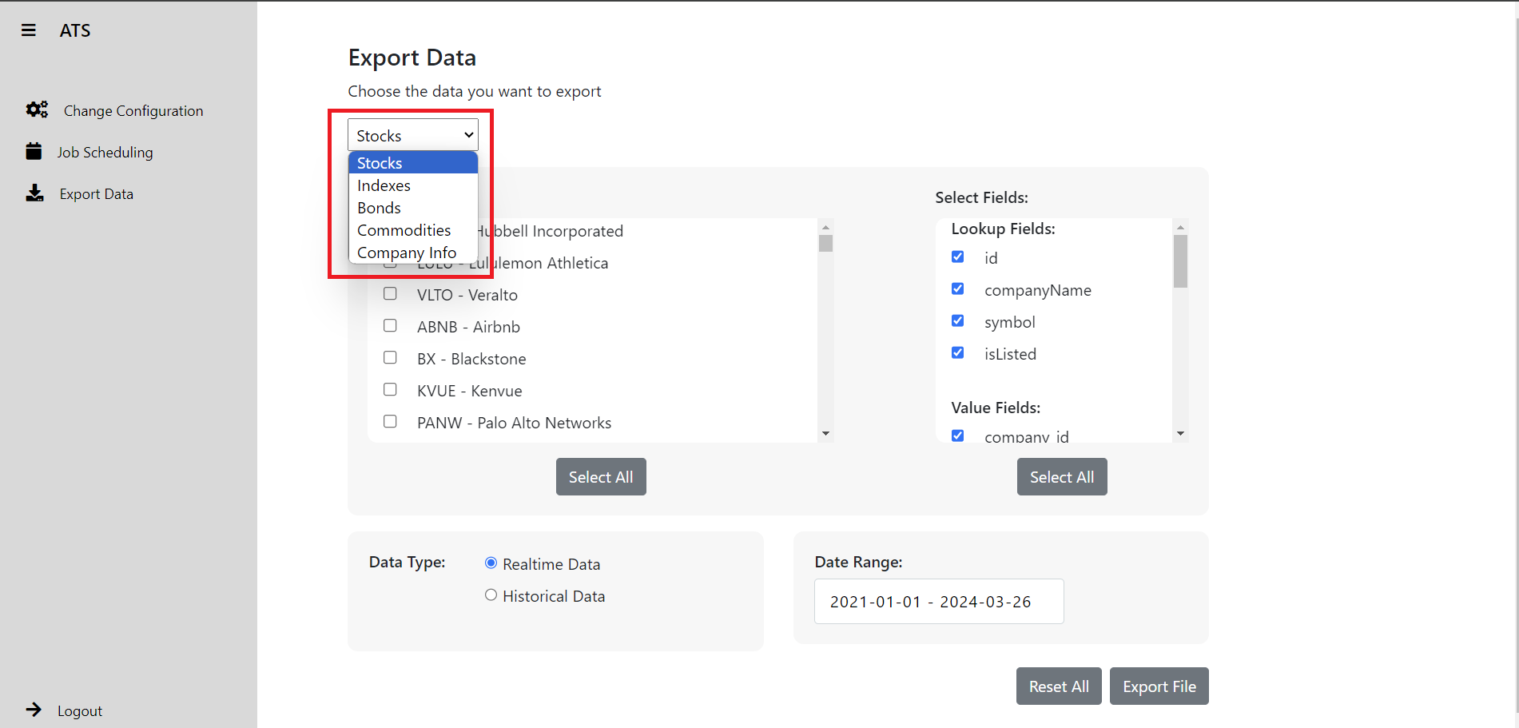

*Figure 6.3.8 Selecting Data to Download*

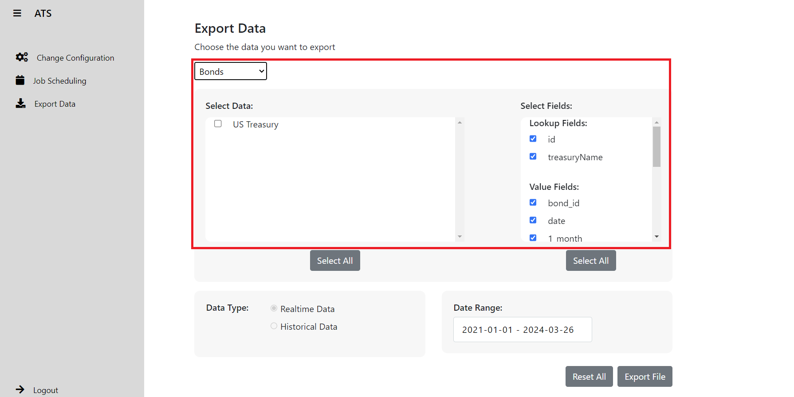

*Figure 6.3.9 Bonds data and fields*

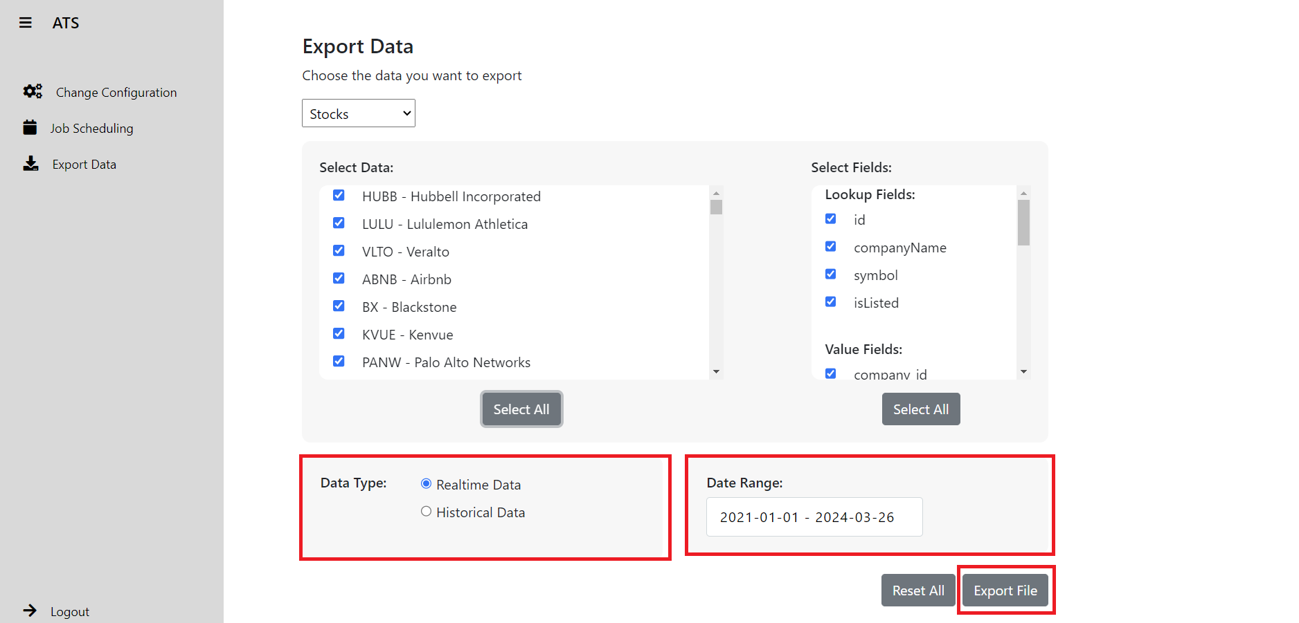

*Figure 6.3.10 Data type, Date range, Export File*

1. **Creating New User** 
   * Once successfully logged in, navigate to Create New User page (*Figure 6.3.11*)
   * Fill in User Information
     1. First name: Type the first name of the new user
     2. Last name: Type the last name of the new user
     3. Username: Enter the desired username for the new user.
     4. Password: Set a password for the new user.
     5. Confirm Password: Re-enter the password to confirm its accuracy.
     6. User Type: Select the appropriate user type from the dropdown menu. Choose either “Admin” or “Basic” based on the user’s role.
   * Once all information is entered, click the “Create User” button.
   * Upon successful creation of the user account, a confirmation message “User created successfully” will be displayed. Otherwise, please ensure that all fields are filled correctly.

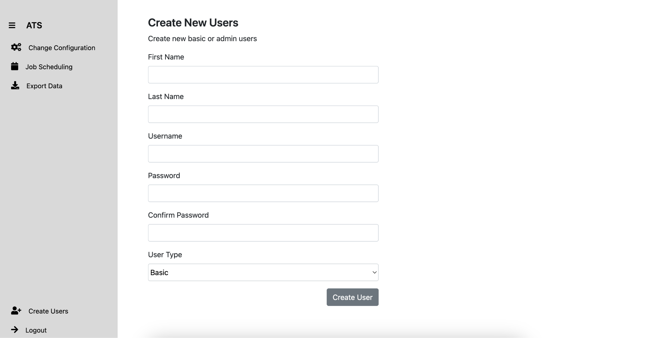

*Figure 6.3.11 ATS Create User Page*

# 4. APPENDIX

## Documentation

IONOS Documentation: <https://docs.ionos.com/cloud/>

phpMyAdmin Documentation: <https://www.phpmyadmin.net/docs/>

MySQL Documentation: <https://dev.mysql.com/doc/>

## Help Page / Manuals

IONOS Help center: <https://www.ionos.ca/help/>

MySQL Reference Manual: <https://dev.mysql.com/doc/refman/8.2/en/>

phpMyAdmin User guide: <https://docs.phpmyadmin.net/en/latest/user.html>